Pre-Authorized Debit (PAD) Agreement

Camp Tulakadik Date: __________

I wish to support Camp Tulakadik through monthly charitable donations.

Please debit my bank account: (Attached Void Cheque or Complete Account Information)

___ $50 ____ $75 ____ $100 Other Amount _________ (specify)
***The Debit will be processed to your account on the 30th of each month or the next business day.

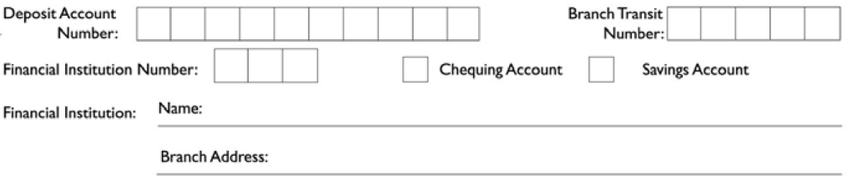

Signature: __________________________________
Donor Name: __________________________________

Address/Contact Information: _______________________________
_______________________________
_______________________________

This donation is made on behalf of: ______ an Individual ______ a Business

****I may revoke my authorization at any time, subject to providing written notice within 10 days of scheduled debit to Camp Tulakadik via the above contact information. To obtain a sample cancellation form, or for more information on my right to cancel a PAD Agreement, I may contact my financial institution or visit www.payments.ca.

****I have certain recourse rights if any debit does not comply with this agreement. For example, I have the right to receive reimbursement for any debit that is not authorized or is not consistent with this PAD Agreement. To obtain more information on my recourse rights, I may contact my financial institution or visit www.payments.ca.

